**How to execute all test –**

1. Open Testrunner.xml from

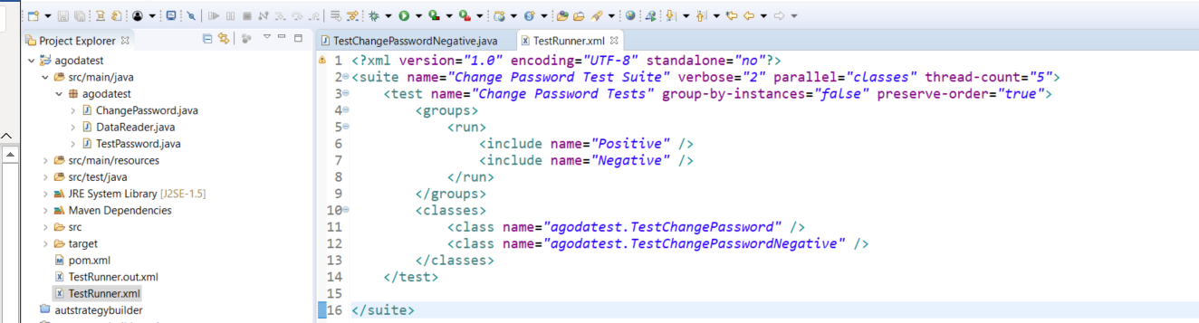

1. Right click on Testrunner.xml from

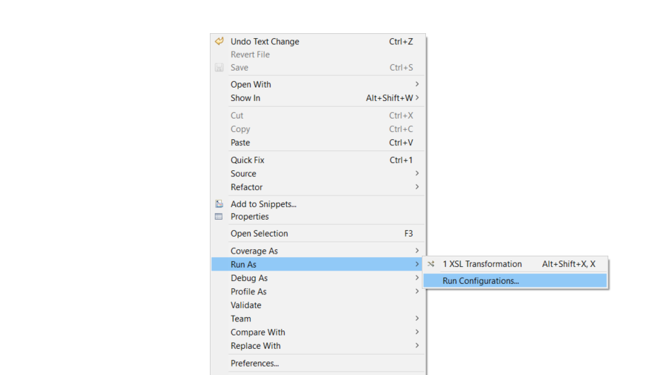

1. Configure Testrunner.xml from and select Suite option

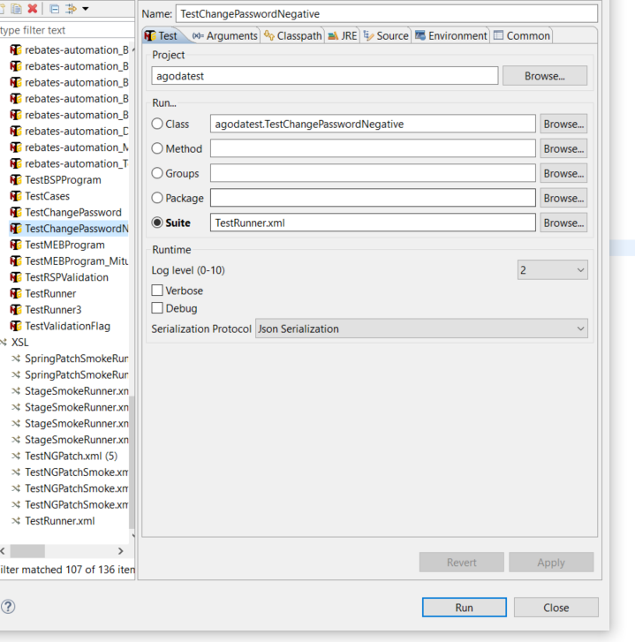

1. Click on run.

**How to see report of executed test**

Select the console output, you will see all the executed test like as below

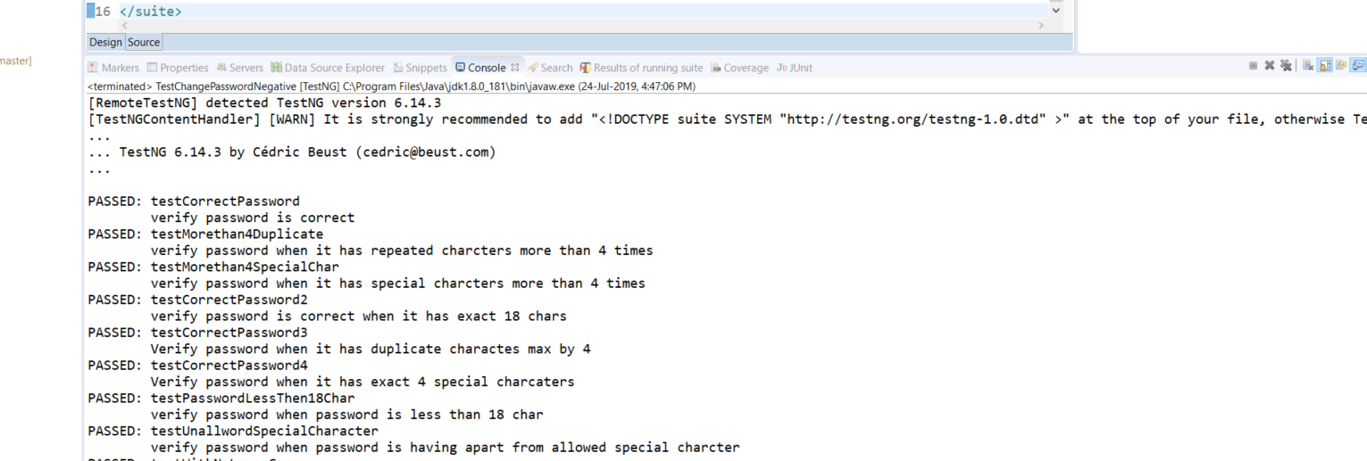

To see html report from test run-

Navigate to test-output folder, look for email ‘emailable-report.html’, open it in any browser

Report will look like below

